Aim :

Create a new process by invoking the appropriate system call. Get the process identifier of the currently running process and its respective parent using system calls and display the same using a C program.

Algorithm :

* Fork the process using system call.
* Check if the fork was successful; if not, print error and exit.
* In the child process, get and print the child's process ID and its parent's process ID.
* In the parent process, get and print the parent's process ID and its parent's process ID.
* Ensure both processes complete properly.
* Exit the program.

Program & Output:

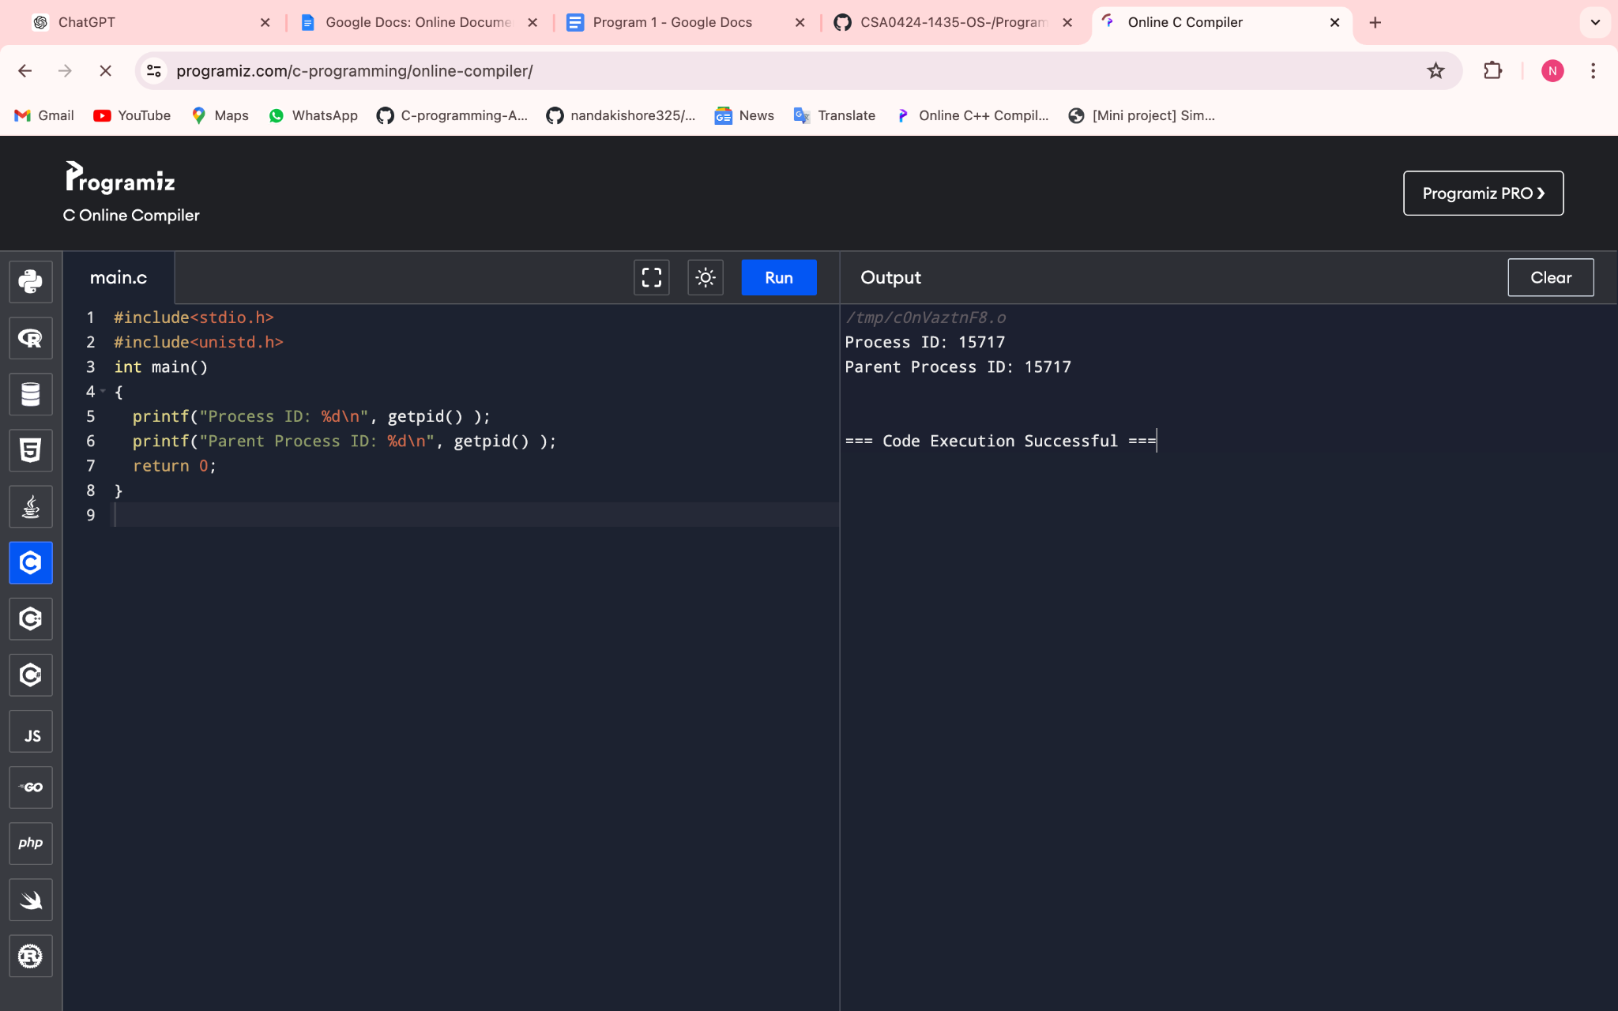

Conclusion : This program correctly demonstrates how to retrieve and print the process ID and the parent process ID using the getpid() and getppid() system calls in C.